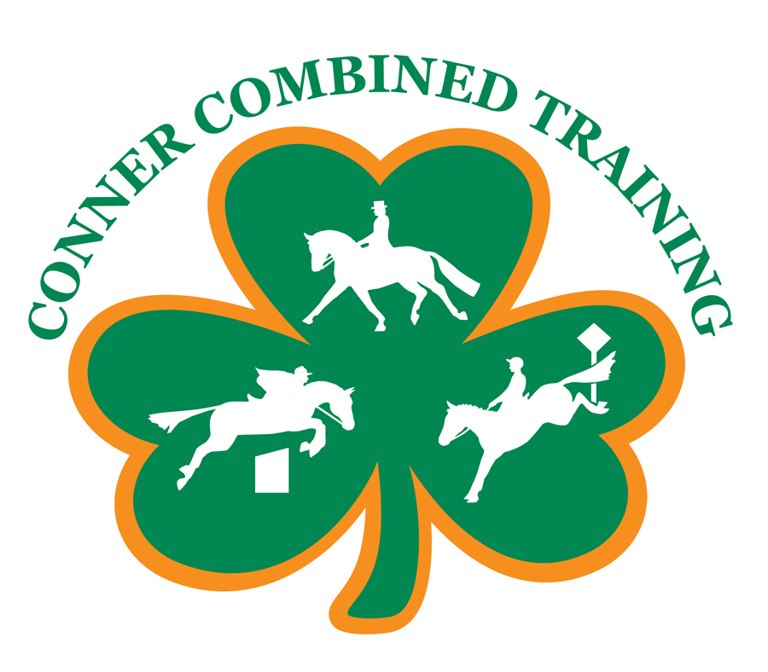
EVENTING/HORSE TRIAL CHECKLIST

ITEMS NEEDED FOR BOTH SCHOOLING SHOWS AND RECOGNIZED SHOWS:

__ Hay net/bag __Standing wraps __ Dressage pad (white, square, black trim)
__ Hay __ Pillow wraps __ Stadium pad* (dressage pad acceptable if A/P)
__ Grain (in bags) __Clay/spray liniment __ Cross-country pad in rider’s colors
__ Carrots/treats __ Splint boots __ Dressage whip
__ 3 Large buckets __ Bell boots __Crop
__ 3 Stud chains __ Running Martingale* __ Breeches for dressage light gray, tan, white
__ Body brush __ Rein stops* __ Black gloves for dressage
__ Face brush __ Saddle(s) __ Tie back or show bow for rider’s hair
__ Tail brush __ Bridle(s) w/ snaffle bits __ Hair net
__ Hoof pick __ Halter and lead rope __ Black or navy helmet for dressage
__ Show Sheen __ Talcum powder* __ Helmet cover for XC* (in rider’s colors)
__ Fly spray* __ Chairs __ Negative Coggins test
__ Horse cooler* __ Water bottle __ Copy of dressage test*
__ Sweat scraper __ Sunscreen __ Umbrella and/or rain gear*
__Shampoo __Tack rack __Waterproof footwear
__ Conditioner __ Armband for XC __ XC safety vest
__Saddle rack __Sponge for bathing horse __XC Air Vest*
__Supplements __Banamine/Bute __Boot socks
__Black belt __Girth __XC Boots for horse
__XC Watch* __Boot bag __ Walking shoes (for walking the XC course)
__Helmet bag __XC Breeches* __ XC Polo shirt in rider’s colors (not white)
__ Manure fork __ Muck bucket __ Saddle soap and sponge for tack
__ Saddle covers __ Horse blanket* __ Small portable tack trunk or grooming kit
__ Tall socks __Riding boots __ Grain (Pre-measured in plastic bags)

ITEMS NEEDED FOR SCHOOLING SHOWS ONLY: (In addition to the above.)
__ Polo-type shirt for dressage (White preferable) __ XC Polo shirt in rider’s colors (white okay)

ITEMS NEEDED FOR RECOGNIZED SHOWS ONLY: (In addition to the above.)
__ Black or navy show jacket (dressage or hunt cut) __ Stock pin
__ White show shirt (long sleeves preferable, short okay) __Sleezy head & neck cover
__ Stock tie (self-tying type preferable) __ Stool to stand on
__ Braiding kit
--rubber bands (small, mane type)
--spray bottle for water
--clips to hold back mane
--yarn (matches mane color)
--seam ripper
--large eye needle
--scissors
--braid aide
--pulling comb

* Indicates optional and/or seasonal

